< Blood Donation Camp-2021 > conducted on <17/09/2021>  GTU &SMS Hospital jointly Organized Blood Donation Camp On the Occasion of 71st Birth Anniversary of Our Hon’Ble Prime Minister Shri Narendrabhai Modi .GTU has Organized Blood Donation Camp in B-0 Hall GTU Chandkheda Campus. Large No Of Students, Staff and 50 GTU PG Students, Family members were participated in Blood Donation Camp. This Event had organized by ​Dept. Of Sports, Youth Affairs & Cultural Activities. | 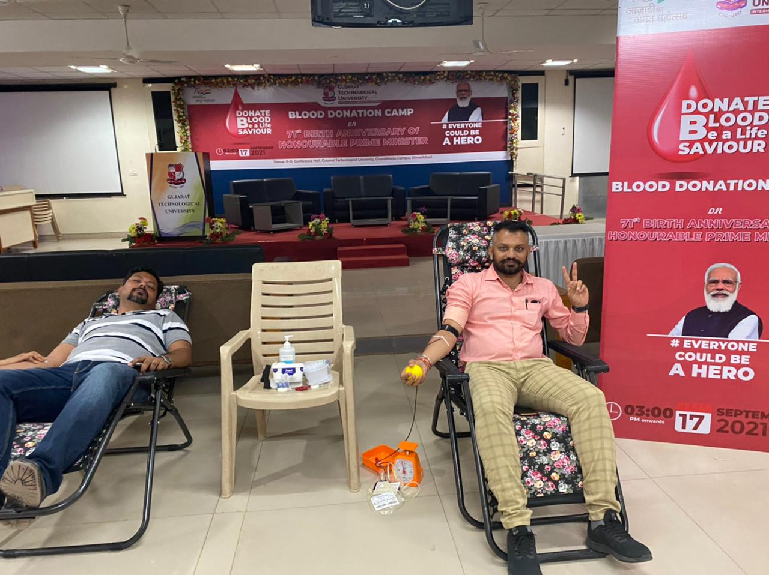  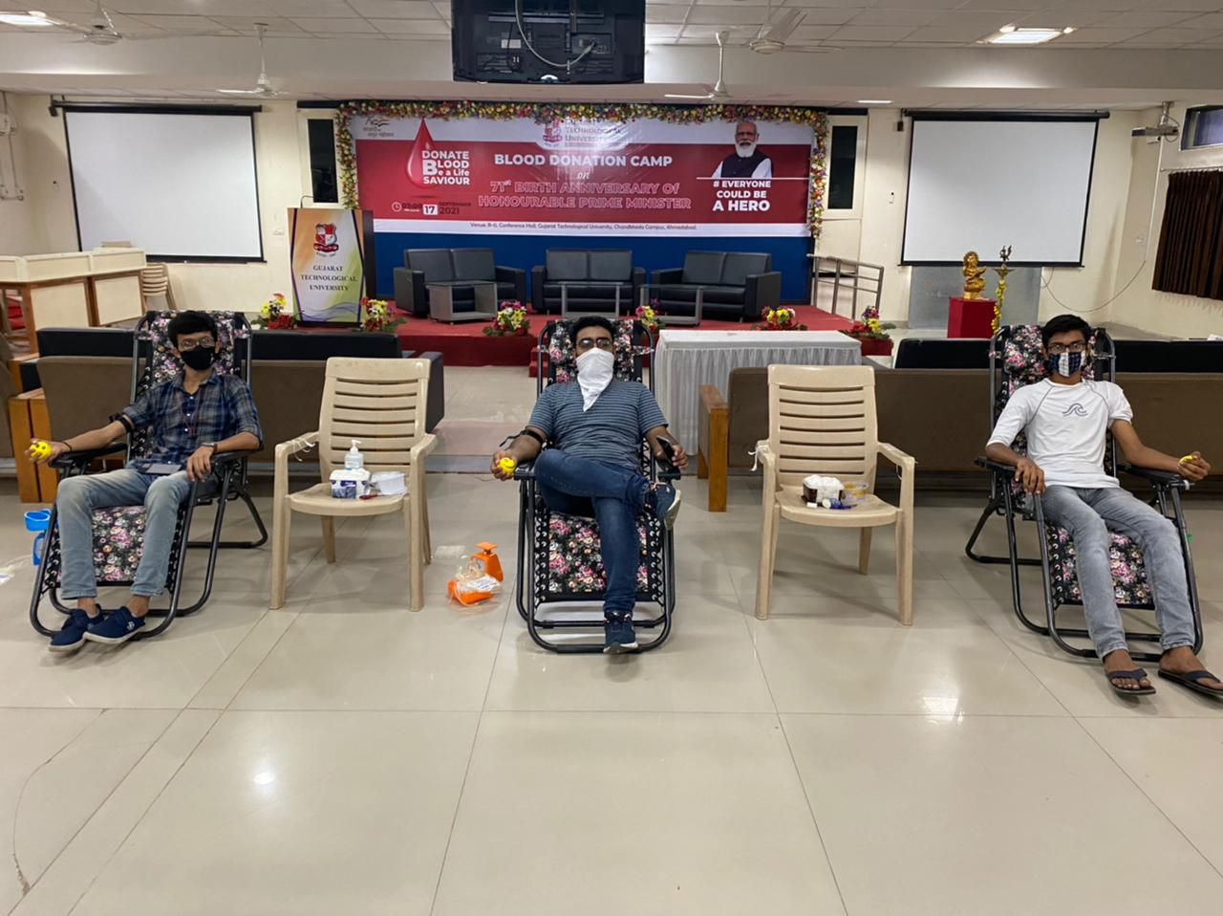

GTU &SMS Hospital jointly Organized Blood Donation Camp On dated 17/09/2021

